Guidelines for Descriptive Analysis / Econometric Estimation

Data

- See new minimum wage Excel file
- Use 2016q1-2025q4 for all estimations, tables and graphs
- Deflate by 2025q4
- Main jobs only
- 18-60 years old (is this what we’ve been working with?)
- Only OCUPADOS with positive earnings, positive hours, non-missing firm size.
- Use usual hours as the baseline. Actual hours contain transitory shocks
- In the case of informal workers, consider only those working at INFORMAL FIRMS
- Exclusions:
  - All public sector workers
  - All domestic workers
  - All self-employed (formal and informal)
  - All Free Trade Zone workers (Zonas Francas)
- HOURLY WAGES to be used for robustness tests

Descriptive Analysis

Summary statistics (all workers)

 | 2016q1 |  | 2025q4
 | Formal | Informal | Formal | Informal
Labor force | 1,775,341 | 2,393,848 | 2,403,395 | 2,832,784
Employment share (in %) | 42.6 | 57.4 | 45.8 | 54.2
Mean wage
Median wage
College (in %)
High School (in %)
Age (Average)
Male (in %)

Note: Focus on these graphs. The rest won’t be needed for now.
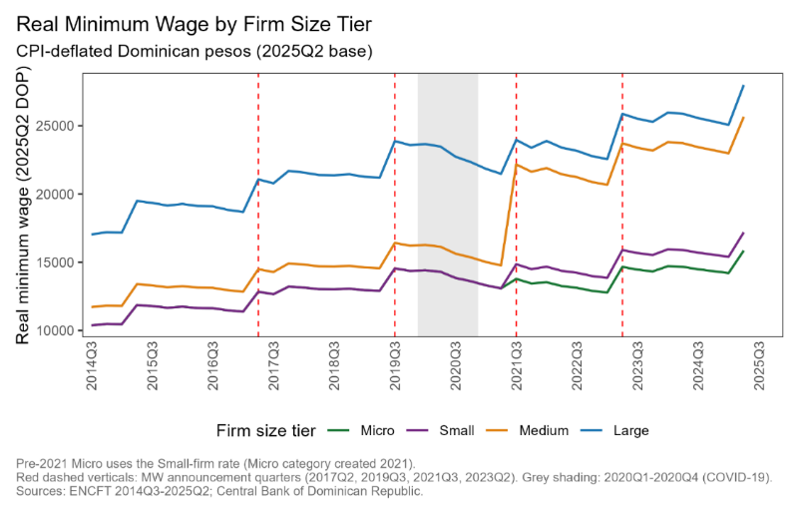 | - Deflate by 2025q4  - Don’t use small firm rate data for pre-micro tier period  - Remove 2014q2-2015q4 and add 2025q3 and q4  - Mark 2025q3 min w increase  - Add 90/10 ratio
 | - Graph variance decomposition of log earnings (Parente Eq. 1) on two partitions: formal/informal and micro/non-micro (within + between components).
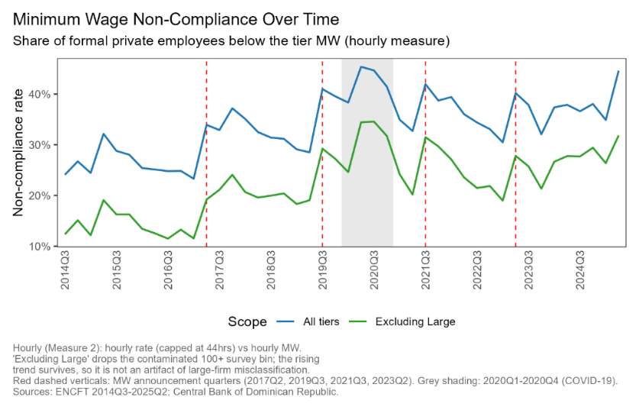 | - Use monthly real minimum wage measure not hourly  - Remove 2014q2-2015q4 and add 2025q3 and q4  - Don’t use small firm rate data for pre-micro tier period  - Mark 2025q3 min w increase  - Compare all tiers vs micro firm tier
- Kaitz index for all tiers and micro firms (since 2021q3)
  - Kaitz = log( floor / median wage)
- Bite in a pre-reform base window
  - Bite = share of workers below the incoming micro floor
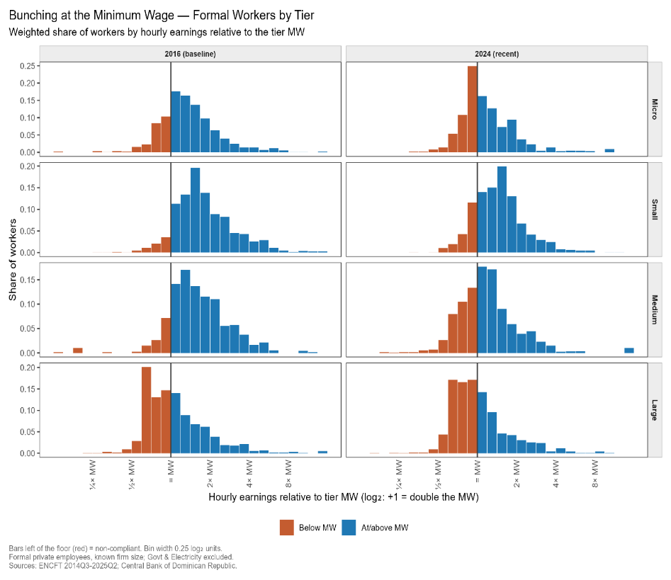 | - Bunching at the micro floor, pre vs post reform.  - Compare micro, small and rest  - Moments:  - 2019q4 (pre-covid)  - 2021q2 (pre-creation of micro tier)  - 2023q1 (after creation of micro tier and before new minimum wage increase)  - 2025q4 (last quarter)

Estimation

Evolution of Inequality Ratios

 | 2019q4  (pre-covid) | 2021q2  (pre-creation of micro tier) | 2023q1  (after micro tier and before new minimum wage increase) | 2025q4  (last quarter)
P90/p10
P90/p50
P50/p10
P10/p40
P80/p20

Re-estimate these graphs following the data guidelines provided
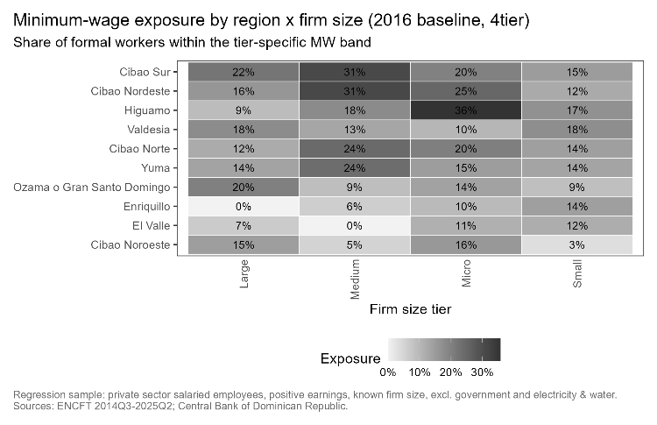 | 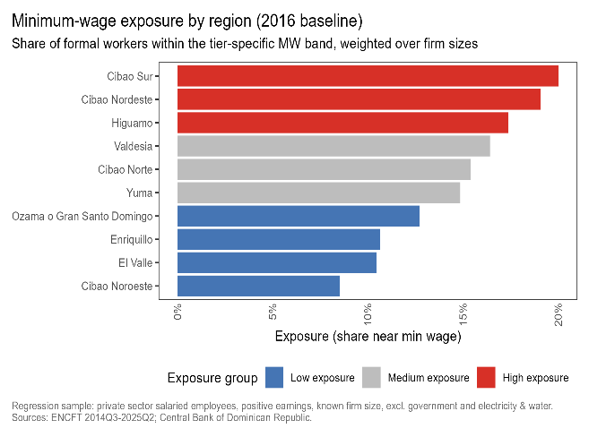
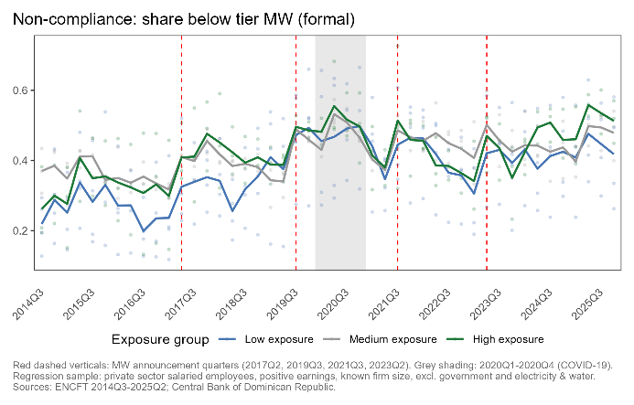 | 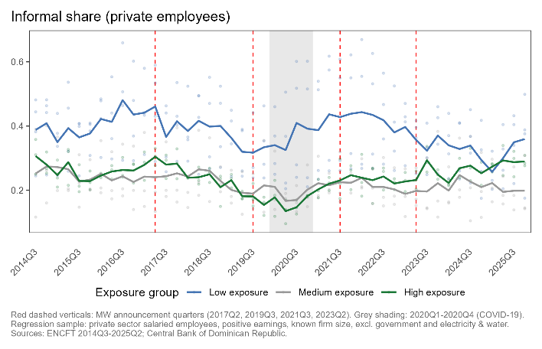
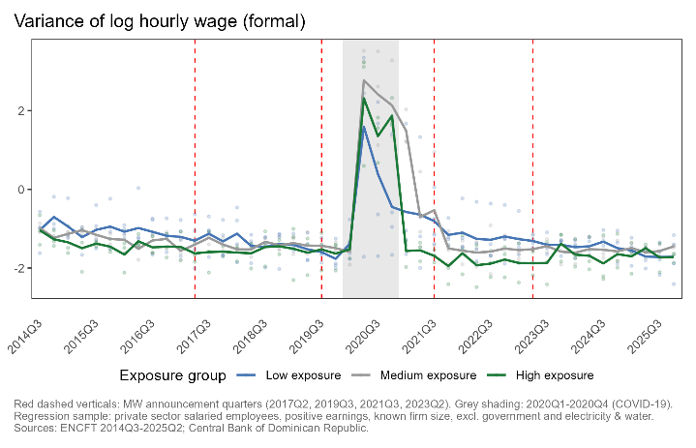 | 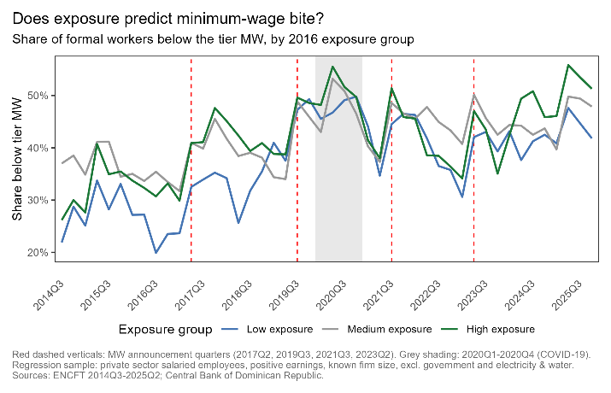

Estimation #1 | Diff-in-diff with 10 regions

- Use data between 2016q1-2025q4. Drop all observations between 2020q1-2020q4
- Rank DR’s 10 development regions by their initial exposure to the micro firm minimum wage (share of micro-firm workers below the incoming micro floor), measured by the share of formal workers in 2021q2 (new baseline)
  - While employment is still recovering by early-to-mid 2021, 2021q2 is the most stable inter-group gap available before the policy, and by 2021q2 the groups have largely recovered relative to the 2020 turmoil.
  - Group the 10 regions into 3 exposure-intensity clusters
- Using only 10 regions may reduce the significance of the coefficients
  - Cluster-robust estimations assume the number of clusters is large — the usual rule of thumb is 30–40+. Standard clustered SEs will over-reject (spurious significance).
  - Must use cluster bootstrap with Webb weights rather than Rademacher
  - Additionally, run randomization/permutation inference — reassign the group labels across regions many times and locate your estimate in the placebo distribution
  - With 10 regions, consider running 4 or 5 groups (roughly 2 regions each) to recover more gradient, trading off precision per group. Alternatively, drop the grouping entirely for a continuous exposure regressor (each region's pre-2021q3 bite interacted with Post), which uses all 10 regions' variation without discretizing — often the better choice when groups are few, and it sidesteps the arbitrariness of tercile cutoffs. The 3-group version stays as the transparent table; the continuous version becomes your efficient specification.
- CNS resolutions frequently split increases into two tranches, making min w increases a two-step adjustment, not a single jump. Treatment options:
- Model the cumulative log floor as a continuous treatment variable interacted with the bite, so both tranches load onto the same coefficient.
- Or define Post at the first tranche and note that post-period effects are a weighted average of partial and full implementation, which understates the full-implementation effect.
- Do not define two overlapping binary events without a staggered-adoption-robust estimator.

Diff-in-diff results
Following Parente et al (2025), estimation of equation (2) and results in Table A.5 (Appendix)

 | log(V^{All}) | log(V^{F}) | log(V^{I}) | log(Inf. Share) | log(Self-emp.)
A. Treatment-intensity groups (baseline = group 1, least exposed)
β₂ (Group 2 × Post) | —  ( ) | —  ( ) | —  ( ) | —  ( ) | —  ( )
β₃ (Group 3 × Post) | —  ( ) | —  ( ) | —  ( ) | —  ( ) | —  ( )
B. Continuous exposure (alternative to grouping)
Bite_{s} × Post | —  ( ) | —  ( ) | —  ( ) | —  ( ) | —  ( )
Fixed effects & controls
Region FE (δ_{s}) | ✓ | ✓ | ✓ | ✓ | ✓
Quarter FE (δ_{t}) | ✓ | ✓ | ✓ | ✓ | ✓
Compositional controls (X_{st}) | ✓ | ✓ | ✓ | ✓ | ✓
Observations | [10×T] | [10×T] | [10×T] | [10×T] | [10×T]
R² | [—] | [—] | [—] | [—] | [—]
Note: ***p<1%, **p<5%, *p<10%. Source: ENCFT 2016q1–2025q4

- Outcomes: Log variance of log earnings overall (V^{All}), formal (V^{F}), informal (V^{I}); log informal employment share; log self-employment share (replaces Parente's log-unemployment column; report log unemployment as an alternative). Observations = 10 regions × T quarters.
- Each column is a separate employment-weighted OLS regression on region×quarter data.
- Panel A
  - $y_{sgt}=α+\sum_{h=2,3}{\sum_{k≠2021q2}{β_{kh}}}∙I_{g=h}∙I_{t=k}+δ_{s}+δ_{t}+Χ_{st}^{'}Γ+ε_{st}$
  - estimates y_sgt = α + Σ^{h=2,3} β_h · 1{g=h} ·
  - Post_t + δ_s + δ_t + X′_st Γ + ε_st,
  - Post_t = 1{t ≥ 2021q3} and base period 2021q2.
  - Group 1 (least exposed) is the omitted baseline, so only β₂ and β₃ are estimated.
- Panel B
  - Replaces the group interactions with a single continuous exposure regressor and is the preferred specification given only three groups.

Event study (dynamic):
y_sgt = α + Σ_{h=2}^{3} Σ_{k ≠ 2021q2} β_kh · 𝟙{g=h} · 𝟙{t=k} + δ_s + δ_t + X′_st Γ + ε_st

Static (the Table X coefficients):
y_sgt = α + Σ_{h=2}^{3} β_h · 𝟙{g=h} · Post_t + δ_s + δ_t + X′_st Γ + ε_st, Post_t = 𝟙{t ≥ 2021q3}

Indices
- s — the region, running s = 1, …, 10 over the DR planning regions. This is the unit of observation crossed with time.
- g — the treatment-intensity group, g = 1, 2, 3. Each region is assigned to exactly one group based on its pre-2021q3 exposure to the micro floor, and that assignment is fixed over time (a region does not move between groups across quarters). Group 1 is the omitted baseline (least exposed), so only g = 2 and g = 3 appear in the sums.
- t — the quarter, over your ENCFT window (e.g. 2016q1 … 2025q4).
- h — the summation index over non-baseline groups. Because group 1 is the reference, h runs only over {2, 3}. Each h gives you one set of coefficients measuring group h relative to group 1. With 3 groups you estimate two group contrasts (β·₂, β·₃).
- k — the summation index over quarters, with the base quarter 2021q2 omitted. In the event-study version you get one coefficient per (group h, quarter k) cell; the omitted 2021q2 is the normalization point against which all pre- and post-introduction quarters are read.

Indicators
- $I_{g=h}$ — equals 1 if region s's fixed group equals h, else 0. A region in group 2 has $I_{g=2}$ =1 and $I_{g=3}$ =0, so its outcome loads only on the β·₂ coefficients.
- $I_{t=k}$ — equals 1 in quarter k, else 0. It selects the quarter whose differential you are reading.
- Post_t = 𝟙{t ≥ 2021q3} — the post-introduction indicator, 1 from 2021q3 onward. In the static equation it replaces the quarter-by-quarter 𝟙{t=k}, collapsing the dynamics into a single average post-introduction effect per group.
- 𝟙{g=h} · 𝟙{t=k} (or 𝟙{g=h} · Post_t) — the interaction that is the treatment. It equals 1 only for regions in group h, only in the treated quarter(s). Everything else in the equation is a nuisance term designed to make this product interpretable as causal.

The coefficients of interest.
- β_kh (event study) — the differential change in the outcome for group h relative to group 1, in quarter k, net of region and quarter fixed effects and controls. The pre-2021q3 β_kh are your parallel-trends test (they should be ≈ 0); the post-2021q3 β_kh trace the dynamic response.
- β_h (static) — the average post-introduction differential for group h vs group 1. These are the numbers that fill your Table X: with 3 groups you report β₂ and β₃ (Parente reported β₂ through β₉). β₃ − β₂ tells you whether the effect strengthens with exposure — your entire dose-response story now rests on that single comparison.
- α — the constant, the baseline level absorbed by the reference region/quarter/group; not interpreted.

The fixed effects.
- δ_s — region fixed effects, one per region (10 parameters). They absorb every time-invariant difference across regions: permanent gaps in average earnings, informality levels, industrial composition, cost of living. They are why β_h is identified from changes within a region, not from cross-sectional level differences between rich and poor regions.
- δ_t — quarter fixed effects, one per quarter. They absorb every shock common to all regions in a given quarter: national macro conditions, the COVID waves, nationwide policy, seasonality. This is the term that nets out the aggregate COVID-recovery path — but only the part common to all regions. Any differential recovery across your 3 groups is not absorbed here, which is exactly why the triple-difference companion matters at a 2021q3 event.

The controls.
- X_st — a vector of time-varying, region-level composition controls: shares by age, sex, education/skill, and sector in region s at quarter t. These absorb changes in who is in the regional labor force that could move inequality or informality independently of the micro floor (e.g. an education upgrade that mechanically lowers informality). Parente uses age, gender, race, education, and the unemployment rate; you would drop race (not the salient DR margin) and, given the DR, consider adding a self-employment-composition control.
- Γ — the coefficient vector on X_st. Usually reported as nuisance (or in a controls block), not the object of interest.

The error and inference.
- ε_st — the region-quarter error, clustered at the region level. This is where your geometry bites hardest, and it deserves its own treatment below.

Estimation #2 | Diff-in-diff with 32 provinces

- Add alternative estimation using provinces (32) instead of regions (10).
  - Estimating the finer province level (32 units) in a robustness specification would materially help inference
  - It's worth checking before committing to 10 as the only unit.

Estimation #3 | Incumbent Analysis

- When the micro floor is introduced, the repeated cross-section mixes three different things — incumbents whose pay changes, low-wage workers who exit to informality or nonemployment, and entrants — and the pooled coefficient can't tell them apart.
- The incumbent panel holds the worker fixed so you observe what happened to the same person, which is exactly what isolates the price effect from the selection effect.
- An incumbent is a worker observed employed in a micro firm in a pre-2021q3 quarter, whom we follow forward across their remaining rotation visits.
- First, build the linkage
  - ENCFT rotates dwellings, not people, so the panel identifier follows the household's position in the rotation scheme, not the individual.
  - Link by the combination of the dwelling/household rotation ID and the person's line number within the household, and then you must verify each link
  - Confirm each within-slot match on time-invariant characteristics — sex, and birth date or age advancing by the right amount across quarters — and drop links that fail
  - Expect real attrition: households complete fewer than five visits, people leave, and matches fail validation, so your linked sample will be a selected subset of the cross-section.

PRE-ANALYSIS

POST-ANALYSIS

- Build the person link. ENCFT rotates dwellings, not people, so construct the key from the sampling/geographic identifiers + dwelling + household-within-dwelling + person line number (UPM/PSU, vivienda, hogar, número de orden), plus año and trimestre — verify field names against the current BCRD diccionario, and first check whether recent releases already ship a longitudinal/panel identifier; if so, use it and skip to validation. Stack all quarters and form candidate links as the same slot in consecutive quarters.

- Validate every link — the slot lies when dwellings turn over. Require sex constant; age non-decreasing and rising ≤ ~1 year across the five quarters; relationship-to-head and education broadly consistent. Drop wholesale-composition changes (move-out/move-in signature). Keep a match-quality log (candidates formed vs. validated) for the attrition accounting below.

- Define the incumbent, event time, and base. An incumbent is a worker observed employed, formal, in a micro firm in a pre-2021q3 in-panel quarter; fix that classification at the base visit and never redetermine it, or you reintroduce the selection you're trying to isolate. Base period: the last pre-announcement quarter (2021q2 if the resolution published in 2021q3; earlier if pre-announced). With 2020 in, the event study still uses 2021q2 as the normalization point but now has the deeper τ = −4…−1 pre points behind it.

- Outcomes, two families. Price: log real monthly earnings, main job, same deflator as the rest of the chapter. Reallocation: mutually exclusive destination indicators at each τ relative to the fixed micro-formal base — remained micro-formal (stayer), → informal employee, → self-employment, → nonemployment/unemployment, → formal in another tier.

- Price equation (within-worker FE event study, DDD form):

y_{i,t} = γ_i + δ_t + λ_{v(i,t)} + Σ_{τ≠−1} β_τ·(Micro_i × 𝟙{t=τ}) + [DDD terms: × Formal_j] + X′{i,t}Θ + ε{i,t}

γ_i = worker FE (the engine); δ_t = calendar-quarter FE; λ_{v(i,t)} = rotation-group / visit-number FE (see step 9); the DDD interaction with the formal-vs-informal-within-micro margin nets the differential recovery. Estimate on incumbents' continuing employed observations.

- Reallocation model (competing risks on fixed incumbents):

Discrete-time hazard or multinomial logit for destination j among pre-period micro-formal incumbents:

P(state_{i,t} = j) = Λ(α_j + δ_t + λ_{v(i,t)} + β_j·(Micro_i × Post_t) + [× Formal_j for DDD] + X′_{i,t}Θ)

Report average marginal effects; a single multinomial (or competing-risks) specification is preferable to separate LPMs so the destination probabilities are jointly estimated and coherent, with LPM as a linear robustness check. β_j is your direct estimate of the informalization and exit margins.

- 2020-specific adjustments (the cost of your decision, managed). First, check whether ENCFT's collection mode or coverage changed in 2020 (fieldwork suspensions/phone substitution were common that year); if so, add a mode/wave control or interaction, because a 2020 measurement break otherwise masquerades as pre-event dynamics. Second, because the baseline sits on the recovery slope, the DDD carries the identification and you should additionally report the estimate with region-specific recovery controls (e.g., a region × linear-recovery trend). Third — the robustness that reviewers will demand — re-estimate dropping the 2020 quarters (reverting to the 2021q1–q2 pre-period from the prior turn) and show the coefficient is stable; if it moves materially, the 2020 quarters are driving the result and you report both transparently rather than only the 2020-included version. Fourth, note that with 2020 in, the 2020-entering cohorts contribute their early visits while 2021 entrants contribute later ones, so cohort and visit-number become correlated — keep the visit FE and check those cells are identified (thin cells are the failure mode).

- Rotation, weights, seams, attrition. Include visit-number (time-in-sample) FE: reported earnings and labor-force status drift with interview number, and since event time and interview number advance together within a worker, that drift would otherwise contaminate β_τ. Use longitudinal weights (BCRD panel weight if it exists, else an inverse-probability-of-valid-match weight modeled on observables) rather than the cross-sectional expansion factors. Screen for seam effects (transitions that cluster at wave boundaries are often re-interview artifacts) before interpreting the transition coefficients. Test attrition directly, and specifically whether it is differential by micro × Post — if micro incumbents exit the panel faster post-2021q3 than controls, that differential attrition is itself an informalization outcome, biases the price regression toward the survivors, and must be documented and absorbed by the transition model.

- The survivorship trap in the wage regression. If you estimate the price effect only on incumbents who remain micro-formal, you condition on survival and understate incidence (the pushed-out are exactly the low-wage ones). Pair the wage coefficient explicitly with the transition model, label it "the price effect for stayers," and if you want a population statement report Lee bounds or an IPW correction for transition-induced selection rather than the raw conditional number.

- Inference. Cluster at the region level (10 clusters); the linked incumbent sample is a fraction of the cross-section and the straddling cohorts are few, so this is the least-precise object in the chapter. Use Webb-weight wild cluster bootstrap and permutation inference as the defaults, and don't chase clusters by dropping to UPM level — that discards the regional correlation you need to account for.

